Flask + MongoDB Atlas Assignment

# 1. Project Overview

This Flask application performs two main tasks:  
• Provides a JSON list at the /api route by reading from a backend file (data.json).  
• Accepts form input on the frontend and stores it in MongoDB Atlas.  
 - On success, the user is redirected to /success.  
 - On error, the error message is displayed on the same form page.

# 2. Folder Structure

Project structure:  
FlaskProject/  
│  
├── app.py # Main Flask application  
├── data.json # JSON data file  
├── templates/  
│ ├── form.html # Form page  
│ └── success.html # Success message page

# 3. API Route (/api)

When the /api route is accessed, Flask reads from data.json and returns the contents as a JSON response.

Code Snippet:

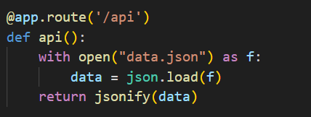

# 4. MongoDB Atlas Setup

1. Create a free MongoDB Atlas cluster.  
2. Create a user with proper credentials.  
3. Add IP Whitelist entry as 0.0.0.0/0 for universal access.  
4. Get a connection URI and use it in your Flask app.

# 5. MongoDB Connection Code

client = MongoClient("mongodb+srv://<Username>:<Password>K@cluster0.ghfnzgu.mongodb.net/?retryWrites=true&w=majority&appName=Cluster0")

db = client["flask_db"]

collection = db["submissions"]

# 6. Running the Flask App

1. Install dependencies:  
 pip install flask pymongo certifi  
2. Start the Flask application:  
 python app.py  
3. Visit in browser:  
 http://127.0.0.1:5000

# 7. GitHub Repository Link

https://github.com/kesarwanikhushi/Flask_assignment

# 8. Screenshots

📌 Screenshot 1: Flask server running

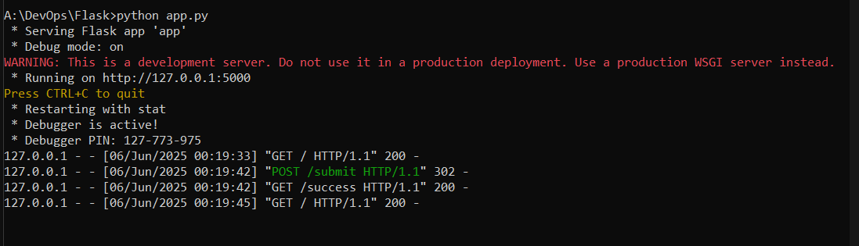

📌 Screenshot 2: Form Page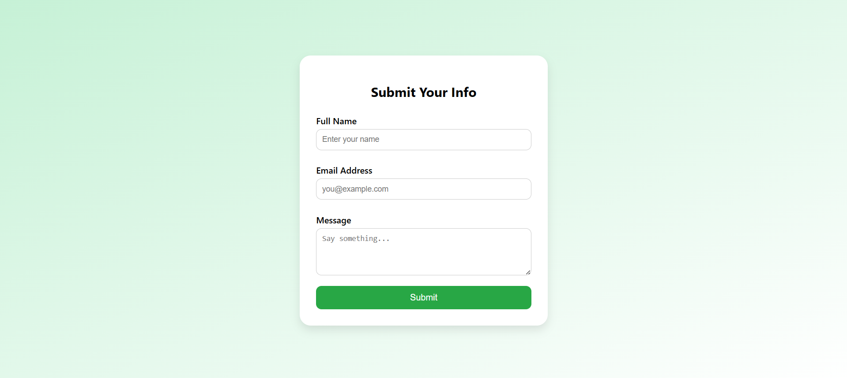

📌 Screenshot 3: Success Page after submission



📌 Screenshot 4: MongoDB Atlas Dashboard showing inserted data